------------------------------------ rf_friedman_mse_1 ------------------------------------

Pre-predictions:

timestamp percentage_current rainfall_current

0 2023-03-06 07:30:00 0.0 0.0

1 2023-03-06 07:35:00 0.0 0.0

2 2023-03-06 07:40:00 0.0 0.0

3 2023-03-06 07:45:00 0.0 0.0

4 2023-03-06 07:50:00 0.0 0.0

5 2023-03-06 07:55:00 0.0 0.0

/home/minorai2/.conda/envs/challenge_5/lib/python3.11/site-packages/sklearn/base.py:348: InconsistentVersionWarning: Trying to unpickle estimator StandardScaler from version 1.3.0 when using version 1.3.1. This might lead to breaking code or invalid results. Use at your own risk. For more info please refer to:

<https://scikit-learn.org/stable/model_persistence.html#security-maintainability-limitations>

warnings.warn(

Metrics for this specific prediction:

Accuracy: 99.99%

Mean squared error: 0.11889918718243127

Variance (R²) score: 1.00

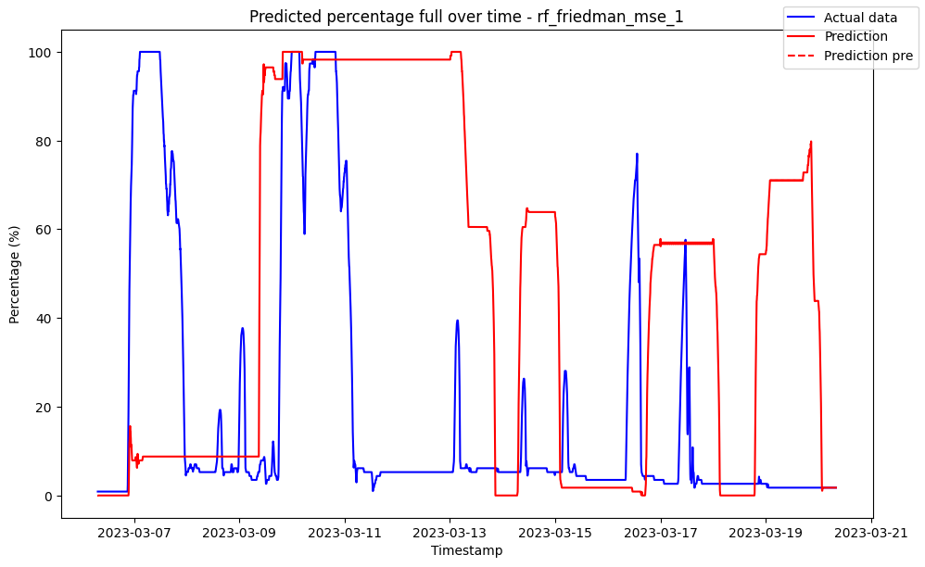

------------------------------------ rf_friedman_mse_10 ------------------------------------

Pre-predictions:

timestamp percentage_current rainfall_current

0 2023-03-06 07:30:00 0.0 0.0

1 2023-03-06 07:35:00 0.0 0.0

2 2023-03-06 07:40:00 0.0 0.0

3 2023-03-06 07:45:00 0.0 0.0

4 2023-03-06 07:50:00 0.0 0.0

5 2023-03-06 07:55:00 0.0 0.0

Metrics for this specific prediction:

Accuracy: 99.99%

Mean squared error: 0.09322840730006902

Variance (R²) score: 1.00

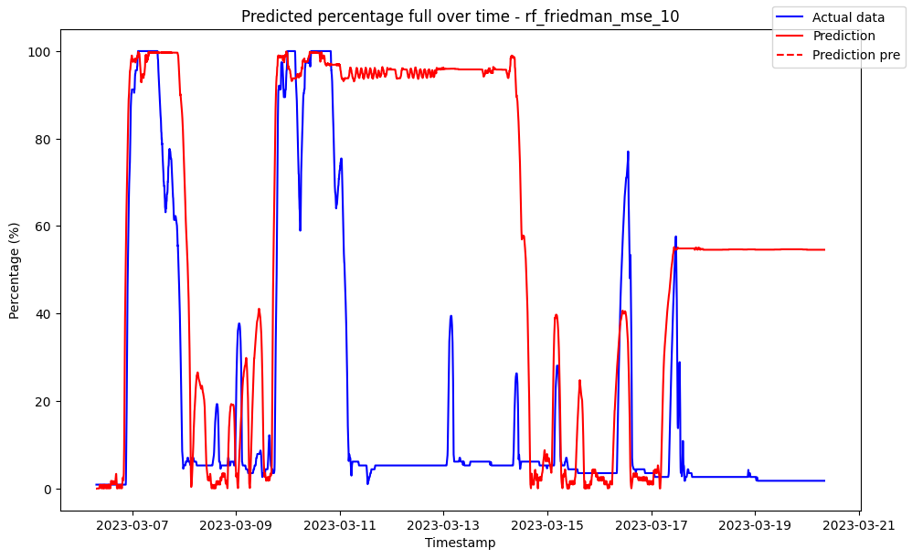

------------------------------------ rf_friedman_mse_2 ------------------------------------

Pre-predictions:

timestamp percentage_current rainfall_current

0 2023-03-06 07:30:00 0.0 0.0

1 2023-03-06 07:35:00 0.0 0.0

2 2023-03-06 07:40:00 0.0 0.0

3 2023-03-06 07:45:00 0.0 0.0

4 2023-03-06 07:50:00 0.0 0.0

5 2023-03-06 07:55:00 0.0 0.0

Metrics for this specific prediction:

Accuracy: 99.99%

Mean squared error: 0.10429214797136306

Variance (R²) score: 1.00

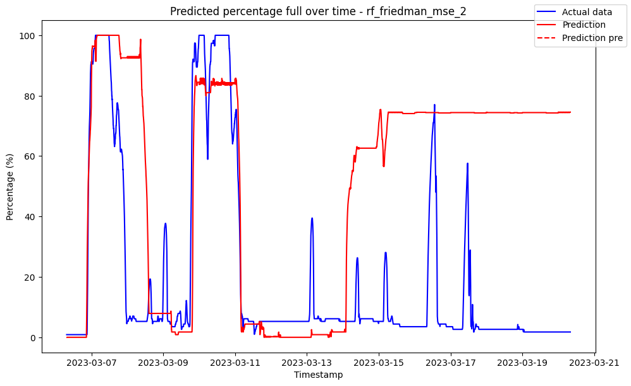

------------------------------------ rf_friedman_mse_3 ------------------------------------

Pre-predictions:

timestamp percentage_current rainfall_current

0 2023-03-06 07:30:00 0.0 0.0

1 2023-03-06 07:35:00 0.0 0.0

2 2023-03-06 07:40:00 0.0 0.0

3 2023-03-06 07:45:00 0.0 0.0

4 2023-03-06 07:50:00 0.0 0.0

5 2023-03-06 07:55:00 0.0 0.0

Metrics for this specific prediction:

Accuracy: 99.99%

Mean squared error: 0.13169896779748919

Variance (R²) score: 1.00

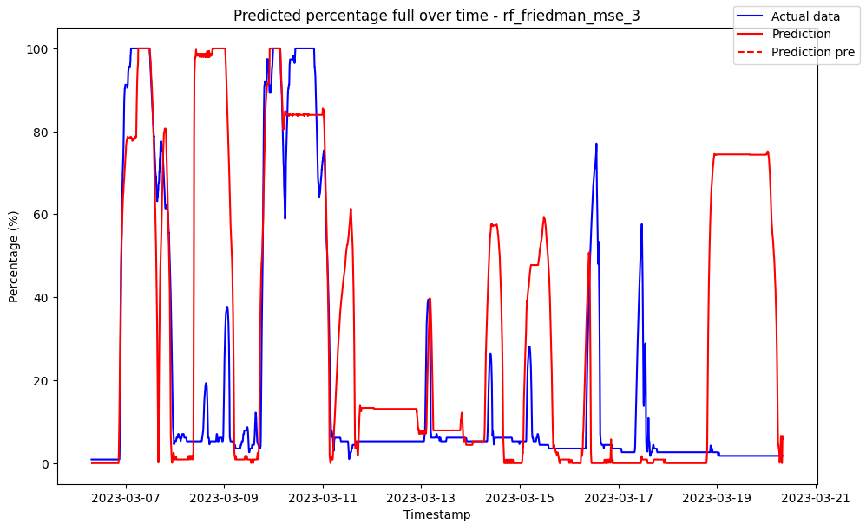

------------------------------------ rf_friedman_mse_4 ------------------------------------

Pre-predictions:

timestamp percentage_current rainfall_current

0 2023-03-06 07:30:00 0.0 0.0

1 2023-03-06 07:35:00 0.0 0.0

2 2023-03-06 07:40:00 0.0 0.0

3 2023-03-06 07:45:00 0.0 0.0

4 2023-03-06 07:50:00 0.0 0.0

5 2023-03-06 07:55:00 0.0 0.0

Metrics for this specific prediction:

Accuracy: 99.99%

Mean squared error: 0.11002280868217633

Variance (R²) score: 1.00

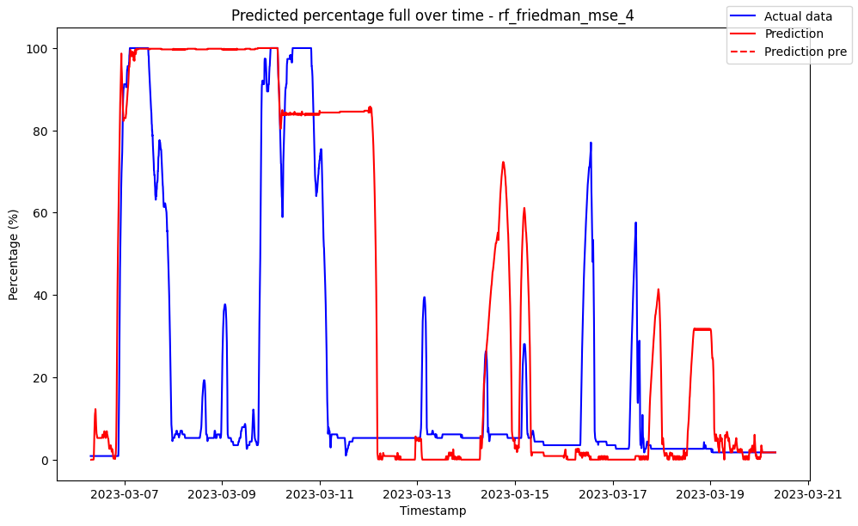

------------------------------------ rf_friedman_mse_5 ------------------------------------

Pre-predictions:

timestamp percentage_current rainfall_current

0 2023-03-06 07:30:00 0.0 0.0

1 2023-03-06 07:35:00 0.0 0.0

2 2023-03-06 07:40:00 0.0 0.0

3 2023-03-06 07:45:00 0.0 0.0

4 2023-03-06 07:50:00 0.0 0.0

5 2023-03-06 07:55:00 0.0 0.0

Metrics for this specific prediction:

Accuracy: 99.99%

Mean squared error: 0.09396341499245241

Variance (R²) score: 1.00

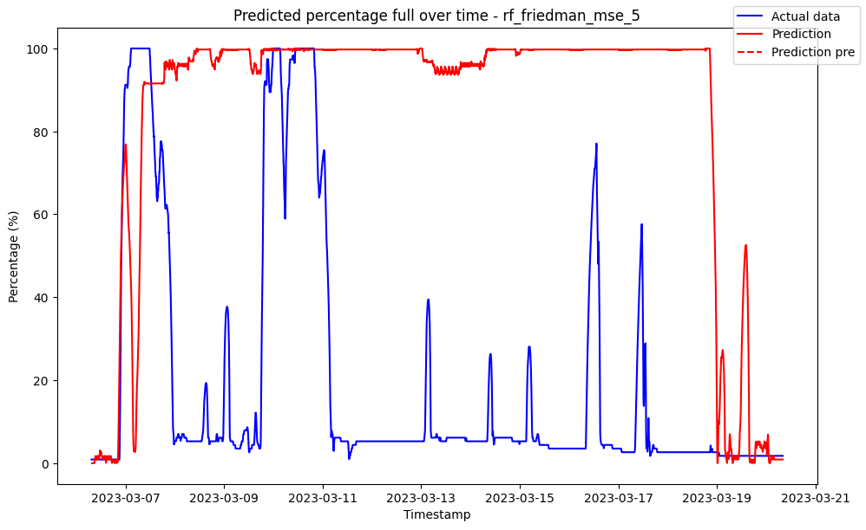

------------------------------------ rf_friedman_mse_6 ------------------------------------

Pre-predictions:

timestamp percentage_current rainfall_current

0 2023-03-06 07:30:00 0.0 0.0

1 2023-03-06 07:35:00 0.0 0.0

2 2023-03-06 07:40:00 0.0 0.0

3 2023-03-06 07:45:00 0.0 0.0

4 2023-03-06 07:50:00 0.0 0.0

5 2023-03-06 07:55:00 0.0 0.0

Metrics for this specific prediction:

Accuracy: 99.99%

Mean squared error: 0.08802422015342841

Variance (R²) score: 1.00

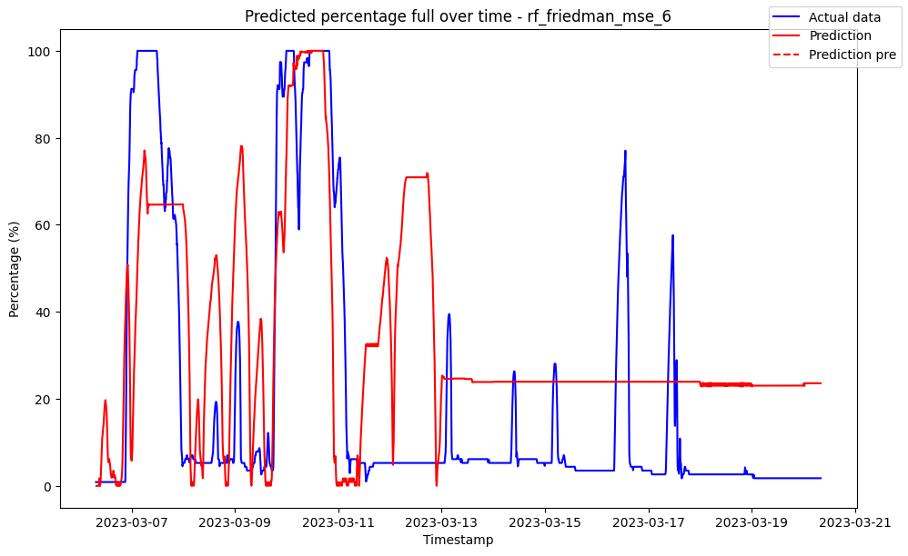

------------------------------------ rf_friedman_mse_7 ------------------------------------

Pre-predictions:

timestamp percentage_current rainfall_current

0 2023-03-06 07:30:00 0.0 0.0

1 2023-03-06 07:35:00 0.0 0.0

2 2023-03-06 07:40:00 0.0 0.0

3 2023-03-06 07:45:00 0.0 0.0

4 2023-03-06 07:50:00 0.0 0.0

5 2023-03-06 07:55:00 0.0 0.0

Metrics for this specific prediction:

Accuracy: 99.99%

Mean squared error: 0.08524058589113559

Variance (R²) score: 1.00

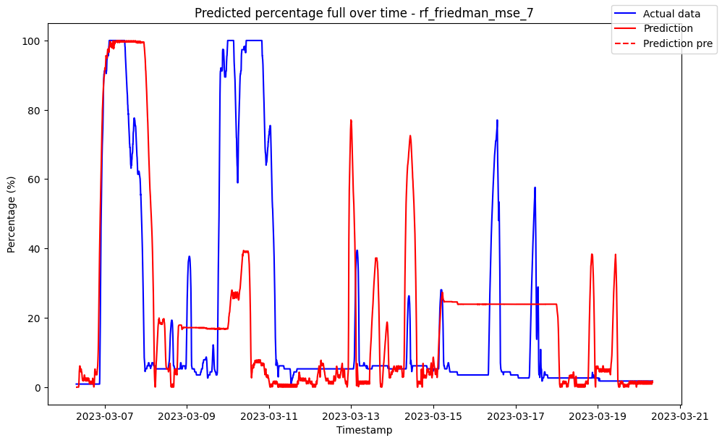

------------------------------------ rf_friedman_mse_8 ------------------------------------

Pre-predictions:

timestamp percentage_current rainfall_current

0 2023-03-06 07:30:00 0.0 0.0

1 2023-03-06 07:35:00 0.0 0.0

2 2023-03-06 07:40:00 0.0 0.0

3 2023-03-06 07:45:00 0.0 0.0

4 2023-03-06 07:50:00 0.0 0.0

5 2023-03-06 07:55:00 0.0 0.0

Metrics for this specific prediction:

Accuracy: 99.99%

Mean squared error: 0.09562137557142815

Variance (R²) score: 1.00

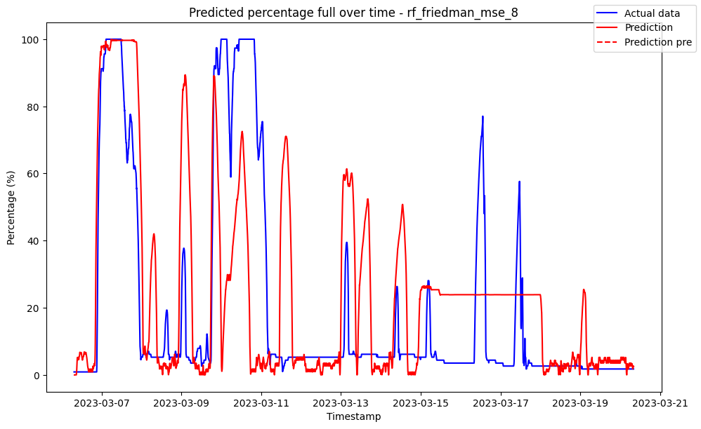

------------------------------------ rf_friedman_mse_9 ------------------------------------

Pre-predictions:

timestamp percentage_current rainfall_current

0 2023-03-06 07:30:00 0.0 0.0

1 2023-03-06 07:35:00 0.0 0.0

2 2023-03-06 07:40:00 0.0 0.0

3 2023-03-06 07:45:00 0.0 0.0

4 2023-03-06 07:50:00 0.0 0.0

5 2023-03-06 07:55:00 0.0 0.0

Metrics for this specific prediction:

Accuracy: 99.99%

Mean squared error: 0.09229576223215435

Variance (R²) score: 1.00

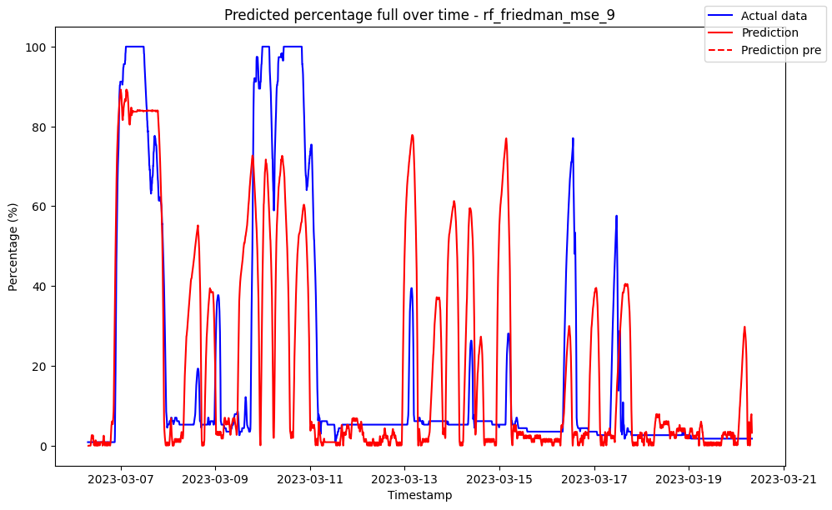

------------------------------------ rf_poisson_1 ------------------------------------

Pre-predictions:

timestamp percentage_current rainfall_current

0 2023-03-06 07:30:00 0.03098 0.0

1 2023-03-06 07:35:00 0.33000 0.0

2 2023-03-06 07:40:00 0.62200 0.0

3 2023-03-06 07:45:00 0.90000 0.0

4 2023-03-06 07:50:00 1.19200 0.0

5 2023-03-06 07:55:00 1.48400 0.0

Metrics for this specific prediction:

Accuracy: 99.98%

Mean squared error: 0.20335599671495727

Variance (R²) score: 1.00

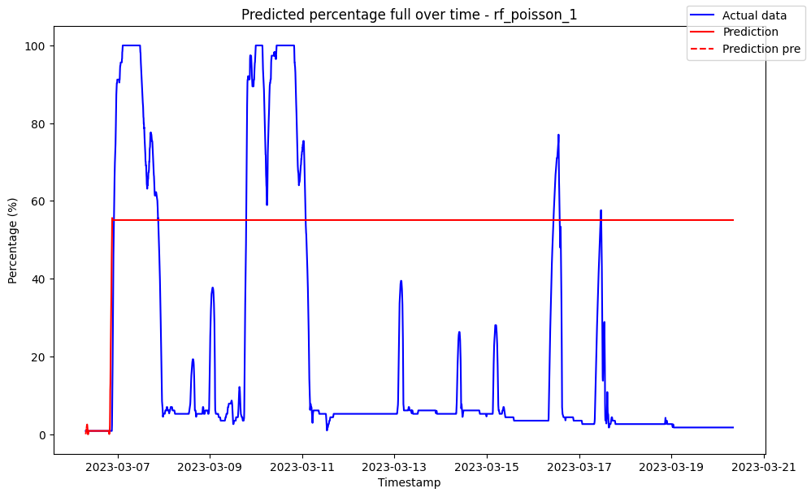

------------------------------------ rf_poisson_10 ------------------------------------

Pre-predictions:

timestamp percentage_current rainfall_current

0 2023-03-06 07:30:00 0.007956 0.0

1 2023-03-06 07:35:00 0.204302 0.0

2 2023-03-06 07:40:00 0.670600 0.0

3 2023-03-06 07:45:00 0.942200 0.0

4 2023-03-06 07:50:00 1.487000 0.0

5 2023-03-06 07:55:00 1.615590 0.0

Metrics for this specific prediction:

Accuracy: 99.99%

Mean squared error: 0.13591066700091603

Variance (R²) score: 1.00

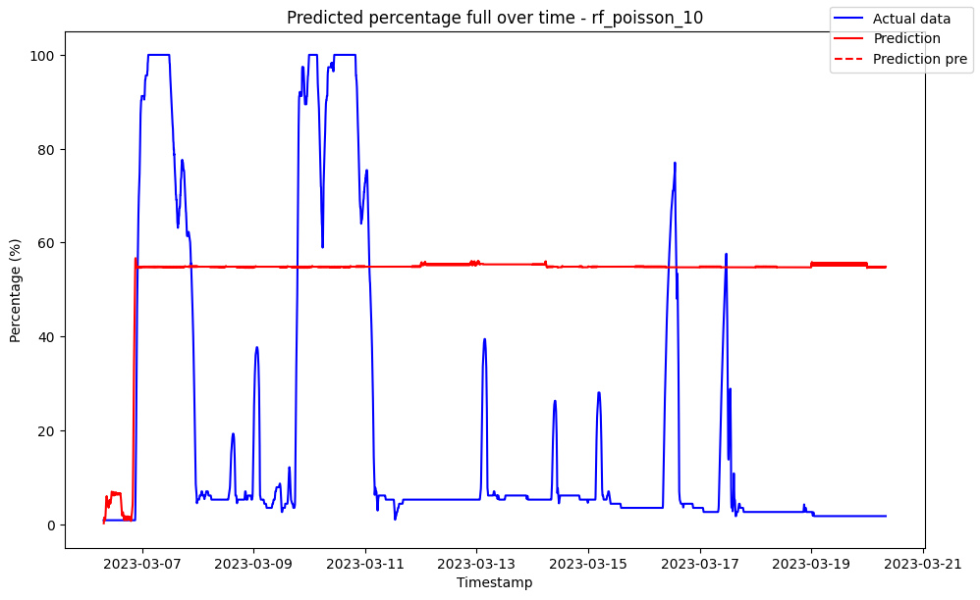

------------------------------------ rf_poisson_2 ------------------------------------

Pre-predictions:

timestamp percentage_current rainfall_current

0 2023-03-06 07:30:00 0.015608 0.0

1 2023-03-06 07:35:00 0.015608 0.0

2 2023-03-06 07:40:00 0.015608 0.0

3 2023-03-06 07:45:00 0.015608 0.0

4 2023-03-06 07:50:00 0.015608 0.0

5 2023-03-06 07:55:00 0.015608 0.0

Metrics for this specific prediction:

Accuracy: 99.99%

Mean squared error: 0.146815360902164

Variance (R²) score: 1.00

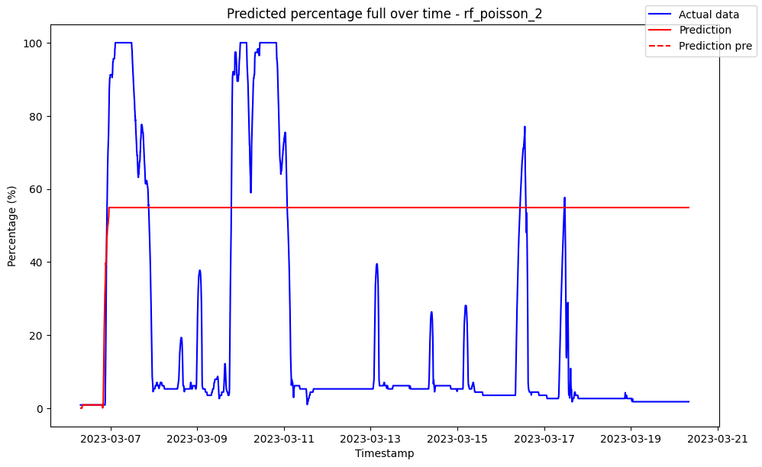

------------------------------------ rf_poisson_3 ------------------------------------

Pre-predictions:

timestamp percentage_current rainfall_current

0 2023-03-06 07:30:00 0.012149 0.0

1 2023-03-06 07:35:00 0.115072 0.0

2 2023-03-06 07:40:00 0.451667 0.0

3 2023-03-06 07:45:00 0.748000 0.0

4 2023-03-06 07:50:00 0.824333 0.0

5 2023-03-06 07:55:00 0.799667 0.0

Metrics for this specific prediction:

Accuracy: 99.98%

Mean squared error: 0.1654210283116798

Variance (R²) score: 1.00

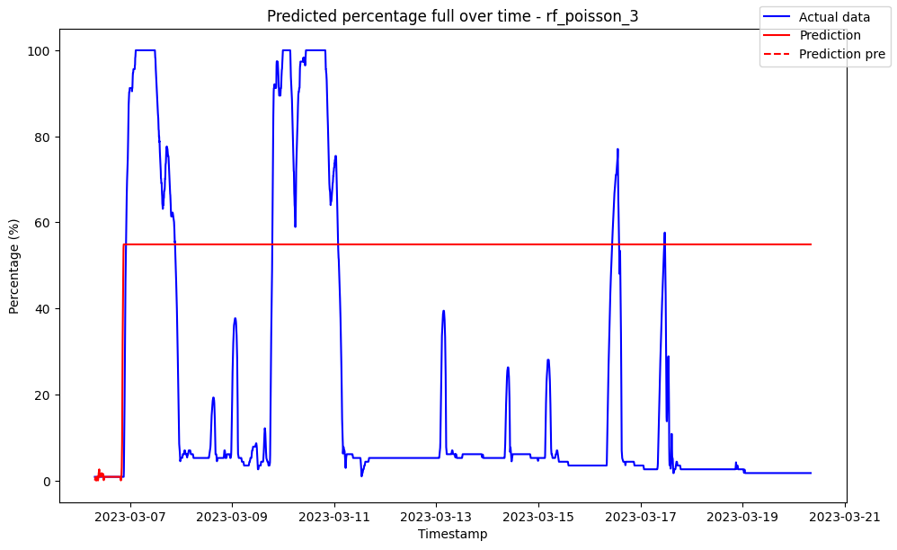

------------------------------------ rf_poisson_4 ------------------------------------

Pre-predictions:

timestamp percentage_current rainfall_current

0 2023-03-06 07:30:00 0.009166 0.0

1 2023-03-06 07:35:00 0.161304 0.0

2 2023-03-06 07:40:00 0.454500 0.0

3 2023-03-06 07:45:00 0.747250 0.0

4 2023-03-06 07:50:00 0.837500 0.0

5 2023-03-06 07:55:00 0.770500 0.0

Metrics for this specific prediction:

Accuracy: 99.99%

Mean squared error: 0.12408472749207182

Variance (R²) score: 1.00

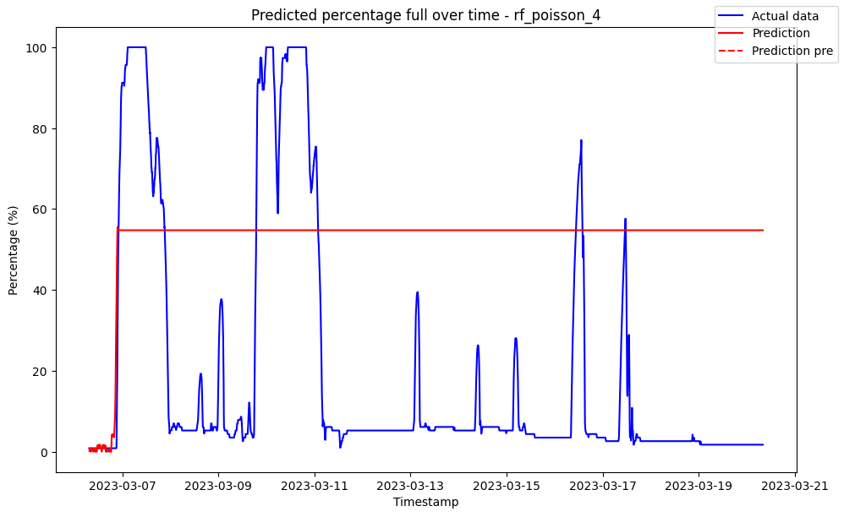

------------------------------------ rf_poisson_5 ------------------------------------

Pre-predictions:

timestamp percentage_current rainfall_current

0 2023-03-06 07:30:00 0.00736 0.0

1 2023-03-06 07:35:00 0.12907 0.0

2 2023-03-06 07:40:00 0.41680 0.0

3 2023-03-06 07:45:00 0.71140 0.0

4 2023-03-06 07:50:00 0.87700 0.0

5 2023-03-06 07:55:00 0.87700 0.0

Metrics for this specific prediction:

Accuracy: 99.99%

Mean squared error: 0.15268848939249055

Variance (R²) score: 1.00

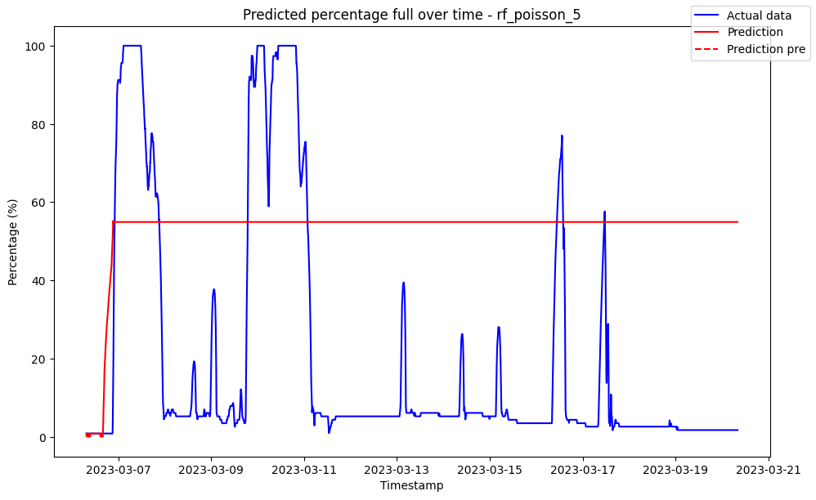

------------------------------------ rf_poisson_6 ------------------------------------

Pre-predictions:

timestamp percentage_current rainfall_current

0 2023-03-06 07:30:00 0.006173 0.0

1 2023-03-06 07:35:00 0.107598 0.0

2 2023-03-06 07:40:00 0.347833 0.0

3 2023-03-06 07:45:00 0.565333 0.0

4 2023-03-06 07:50:00 0.681833 0.0

5 2023-03-06 07:55:00 0.687167 0.0

Metrics for this specific prediction:

Accuracy: 99.99%

Mean squared error: 0.14779644727895558

Variance (R²) score: 1.00

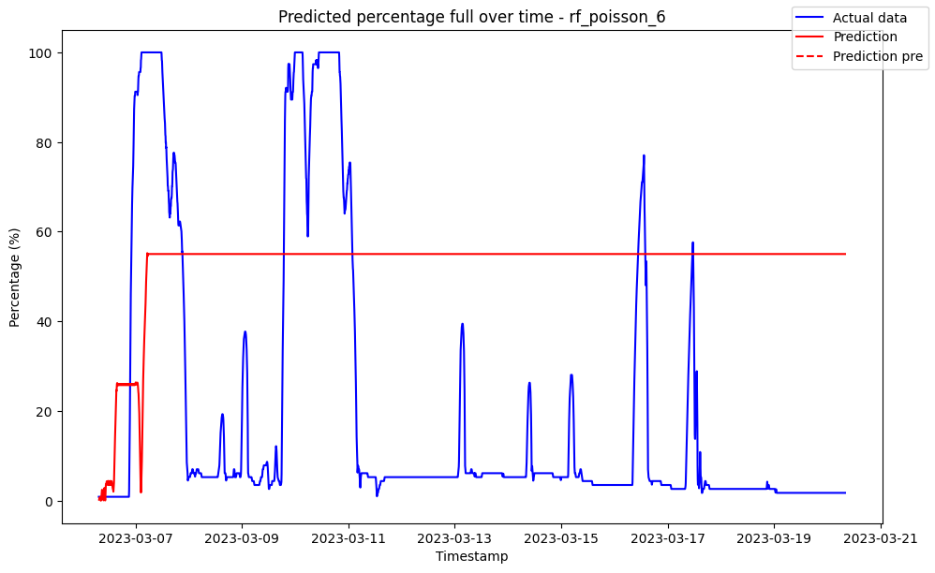

------------------------------------ rf_poisson_7 ------------------------------------

Pre-predictions:

timestamp percentage_current rainfall_current

0 2023-03-06 07:30:00 0.005369 0.0

1 2023-03-06 07:35:00 0.183227 0.0

2 2023-03-06 07:40:00 0.541714 0.0

3 2023-03-06 07:45:00 0.793714 0.0

4 2023-03-06 07:50:00 0.613762 0.0

5 2023-03-06 07:55:00 0.383000 0.0

Metrics for this specific prediction:

Accuracy: 99.99%

Mean squared error: 0.1440117783783107

Variance (R²) score: 1.00

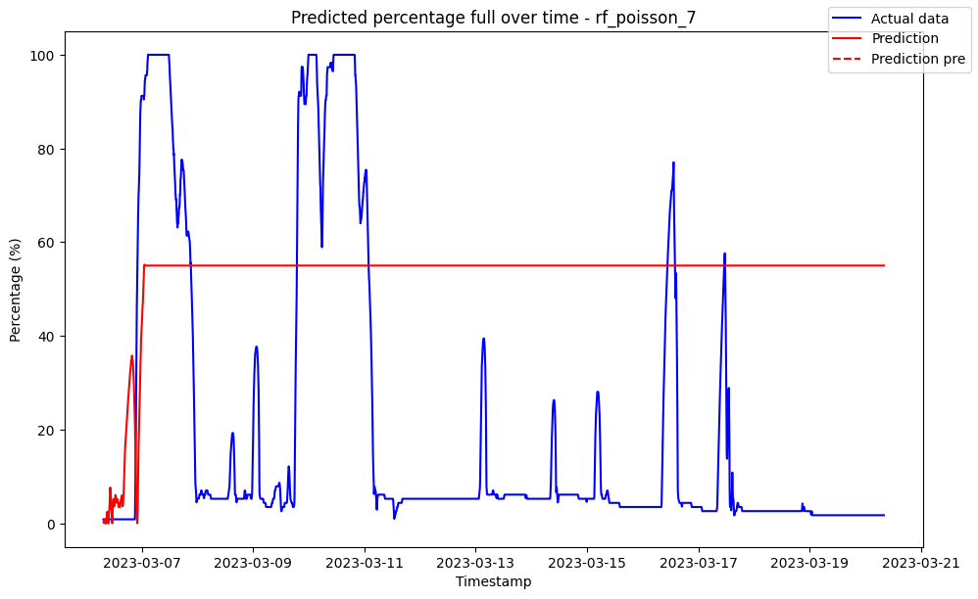

------------------------------------ rf_poisson_8 ------------------------------------

Pre-predictions:

timestamp percentage_current rainfall_current

0 2023-03-06 07:30:00 0.004735 0.0

1 2023-03-06 07:35:00 0.208948 0.0

2 2023-03-06 07:40:00 0.682250 0.0

3 2023-03-06 07:45:00 0.969375 0.0

4 2023-03-06 07:50:00 1.518500 0.0

5 2023-03-06 07:55:00 1.871363 0.0

Metrics for this specific prediction:

Accuracy: 99.98%

Mean squared error: 0.1554462703692412

Variance (R²) score: 1.00

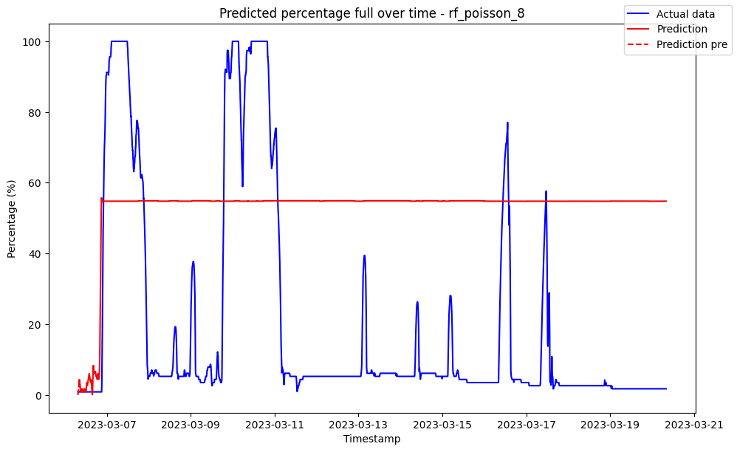

------------------------------------ rf_poisson_9 ------------------------------------

Pre-predictions:

timestamp percentage_current rainfall_current

0 2023-03-06 07:30:00 0.004236 0.0

1 2023-03-06 07:35:00 0.222399 0.0

2 2023-03-06 07:40:00 0.608000 0.0

3 2023-03-06 07:45:00 0.952667 0.0

4 2023-03-06 07:50:00 1.489556 0.0

5 2023-03-06 07:55:00 1.810545 0.0

Metrics for this specific prediction:

Accuracy: 99.99%

Mean squared error: 0.1391114501479147

Variance (R²) score: 1.00

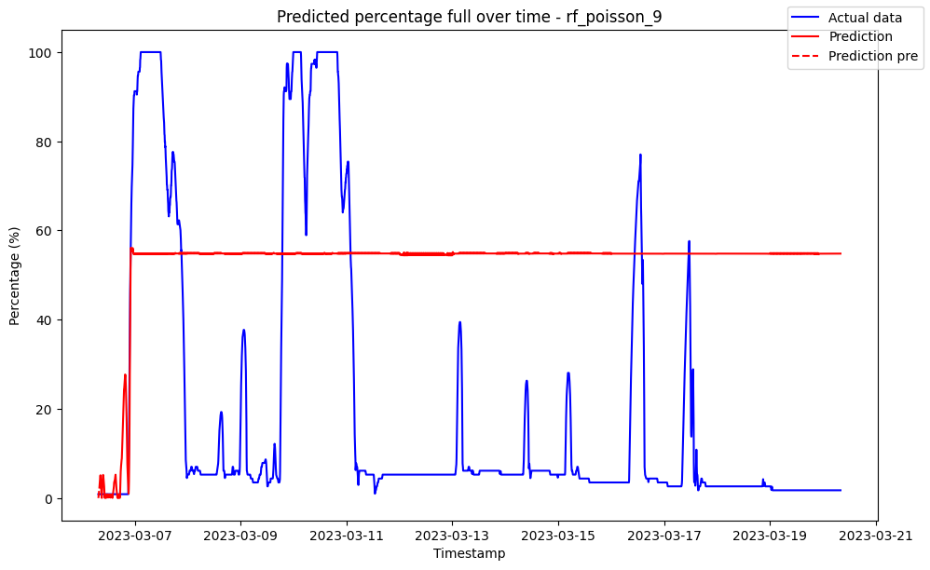

------------------------------------ rf_squared_error_1 ------------------------------------

Pre-predictions:

timestamp percentage_current rainfall_current

0 2023-03-06 07:30:00 0.0 0.0

1 2023-03-06 07:35:00 0.0 0.0

2 2023-03-06 07:40:00 0.0 0.0

3 2023-03-06 07:45:00 0.0 0.0

4 2023-03-06 07:50:00 0.0 0.0

5 2023-03-06 07:55:00 0.0 0.0

Metrics for this specific prediction:

Accuracy: 99.93%

Mean squared error: 0.7536260252490575

Variance (R²) score: 1.00

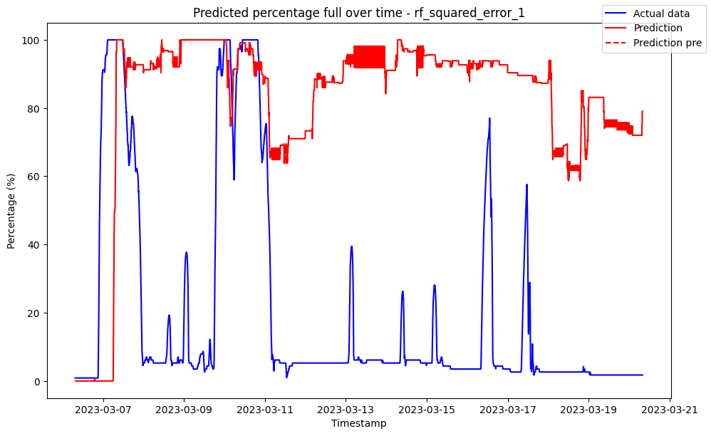

------------------------------------ rf_squared_error_10 ------------------------------------

Pre-predictions:

timestamp percentage_current rainfall_current

0 2023-03-06 07:30:00 0 0.0

1 2023-03-06 07:35:00 0 0.0

2 2023-03-06 07:40:00 0 0.0

3 2023-03-06 07:45:00 0 0.0

4 2023-03-06 07:50:00 0 0.0

5 2023-03-06 07:55:00 0 0.0

Metrics for this specific prediction:

Accuracy: 99.96%

Mean squared error: 0.3776099143202907

Variance (R²) score: 1.00

------------------------------------ rf_squared_error_2 ------------------------------------

Pre-predictions:

timestamp percentage_current rainfall_current

0 2023-03-06 07:30:00 0 0.0

1 2023-03-06 07:35:00 0 0.0

2 2023-03-06 07:40:00 0 0.0

3 2023-03-06 07:45:00 0 0.0

4 2023-03-06 07:50:00 0 0.0

5 2023-03-06 07:55:00 0 0.0

Metrics for this specific prediction:

Accuracy: 99.95%

Mean squared error: 0.5556346264756369

Variance (R²) score: 1.00

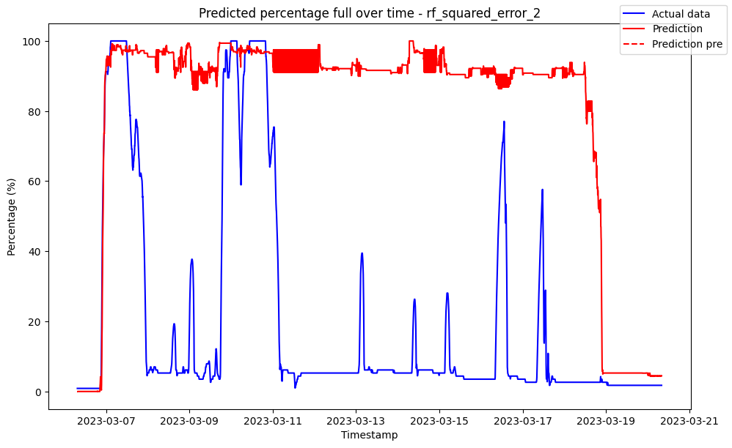

------------------------------------ rf_squared_error_3 ------------------------------------

Pre-predictions:

timestamp percentage_current rainfall_current

0 2023-03-06 07:30:00 0 0.0

1 2023-03-06 07:35:00 0 0.0

2 2023-03-06 07:40:00 0 0.0

3 2023-03-06 07:45:00 0 0.0

4 2023-03-06 07:50:00 0 0.0

5 2023-03-06 07:55:00 0 0.0

Metrics for this specific prediction:

Accuracy: 99.95%

Mean squared error: 0.46930377413828406

Variance (R²) score: 1.00

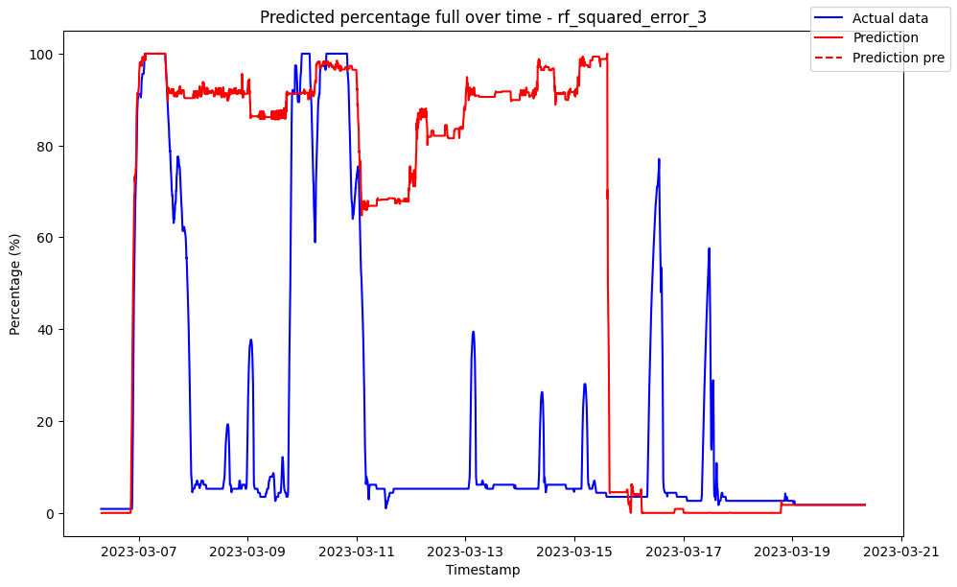

------------------------------------ rf_squared_error_4 ------------------------------------

Pre-predictions:

timestamp percentage_current rainfall_current

0 2023-03-06 07:30:00 0 0.0

1 2023-03-06 07:35:00 0 0.0

2 2023-03-06 07:40:00 0 0.0

3 2023-03-06 07:45:00 0 0.0

4 2023-03-06 07:50:00 0 0.0

5 2023-03-06 07:55:00 0 0.0

Metrics for this specific prediction:

Accuracy: 99.96%

Mean squared error: 0.44908544361530334

Variance (R²) score: 1.00

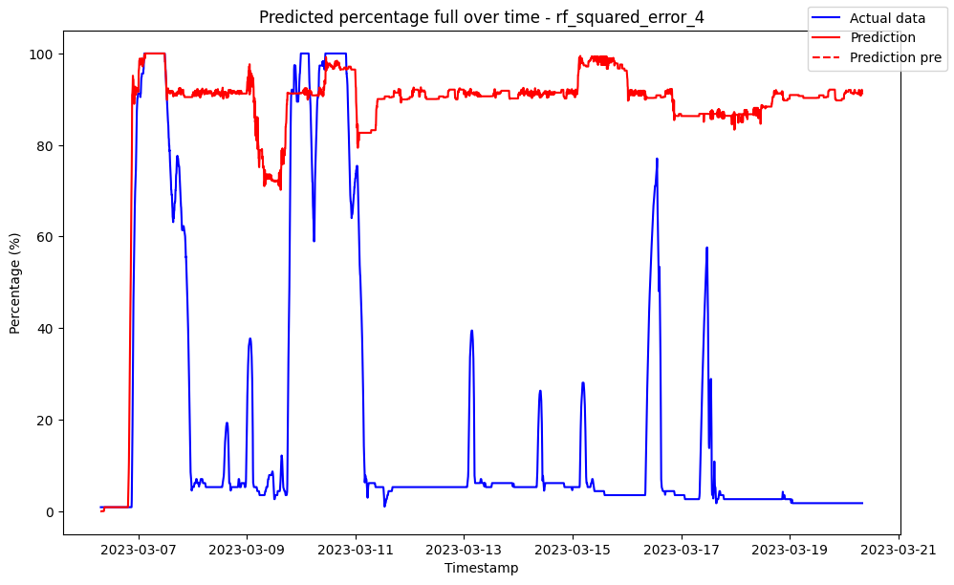

------------------------------------ rf_squared_error_5 ------------------------------------

Pre-predictions:

timestamp percentage_current rainfall_current

0 2023-03-06 07:30:00 0 0.0

1 2023-03-06 07:35:00 0 0.0

2 2023-03-06 07:40:00 0 0.0

3 2023-03-06 07:45:00 0 0.0

4 2023-03-06 07:50:00 0 0.0

5 2023-03-06 07:55:00 0 0.0

Metrics for this specific prediction:

Accuracy: 99.96%

Mean squared error: 0.4168584110026632

Variance (R²) score: 1.00

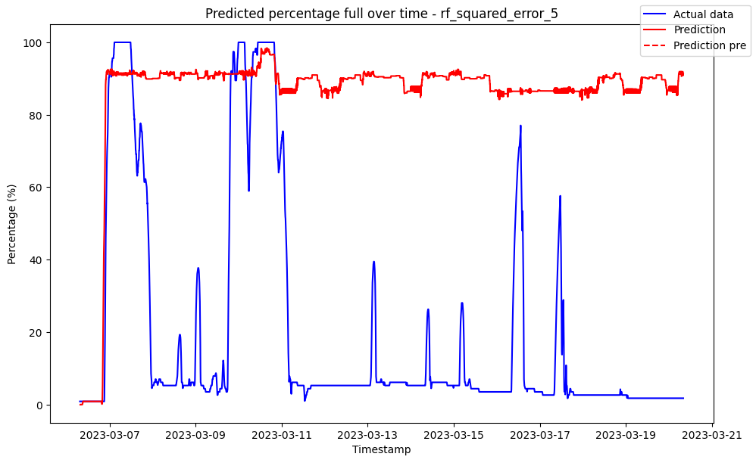

------------------------------------ rf_squared_error_6 ------------------------------------

Pre-predictions:

timestamp percentage_current rainfall_current

0 2023-03-06 07:30:00 0 0.0

1 2023-03-06 07:35:00 0 0.0

2 2023-03-06 07:40:00 0 0.0

3 2023-03-06 07:45:00 0 0.0

4 2023-03-06 07:50:00 0 0.0

5 2023-03-06 07:55:00 0 0.0

Metrics for this specific prediction:

Accuracy: 99.96%

Mean squared error: 0.39161453825033027

Variance (R²) score: 1.00

------------------------------------ rf_squared_error_7 ------------------------------------

Pre-predictions:

timestamp percentage_current rainfall_current

0 2023-03-06 07:30:00 0 0.0

1 2023-03-06 07:35:00 0 0.0

2 2023-03-06 07:40:00 0 0.0

3 2023-03-06 07:45:00 0 0.0

4 2023-03-06 07:50:00 0 0.0

5 2023-03-06 07:55:00 0 0.0

Metrics for this specific prediction:

Accuracy: 99.96%

Mean squared error: 0.38626237788207046

Variance (R²) score: 1.00

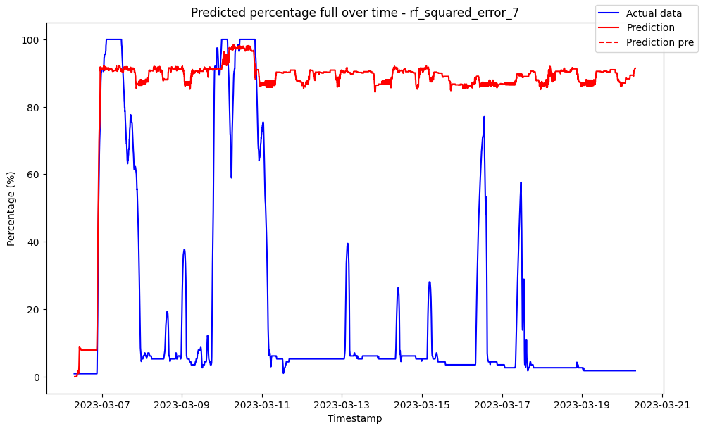

------------------------------------ rf_squared_error_8 ------------------------------------

Pre-predictions:

timestamp percentage_current rainfall_current

0 2023-03-06 07:30:00 0 0.0

1 2023-03-06 07:35:00 0 0.0

2 2023-03-06 07:40:00 0 0.0

3 2023-03-06 07:45:00 0 0.0

4 2023-03-06 07:50:00 0 0.0

5 2023-03-06 07:55:00 0 0.0

Metrics for this specific prediction:

Accuracy: 99.96%

Mean squared error: 0.37686691193383

Variance (R²) score: 1.00

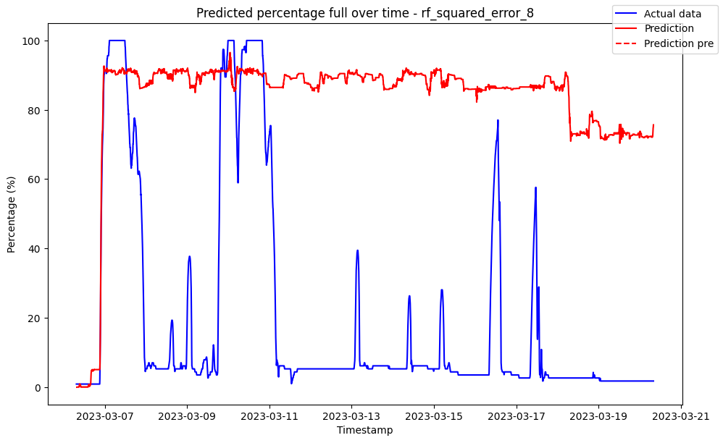

------------------------------------ rf_squared_error_9 ------------------------------------

Pre-predictions:

timestamp percentage_current rainfall_current

0 2023-03-06 07:30:00 0 0.0

1 2023-03-06 07:35:00 0 0.0

2 2023-03-06 07:40:00 0 0.0

3 2023-03-06 07:45:00 0 0.0

4 2023-03-06 07:50:00 0 0.0

5 2023-03-06 07:55:00 0 0.0

Metrics for this specific prediction:

Accuracy: 99.96%

Mean squared error: 0.37386275779250944

Variance (R²) score: 1.00

